NOTICE REGARDING WELLNESS PROGRAM

[Name of wellness program] is a voluntary wellness program available to all employees. The program is administered according to federal rules permitting employer-sponsored wellness programs that seek to improve employee health or prevent disease, including the Americans with Disabilities Act of 1990, the Genetic Information Nondiscrimination Act of 2008, and the Health Insurance Portability and Accountability Act, as applicable, among others.

Wellness Program Components
If you choose to participate in the wellness program, you will be asked to:

- complete a voluntary health risk assessment or "H6RA" that asks a series of questions about your health-related activities and behaviors and whether you have or had certain medical conditions (e.g., cancer, diabetes, or heart disease).
- complete a biometric screening, which will include a blood test for [be specific about the conditions for which blood will be tested]
- [other wellness programs: provide specific details, including any required health related outcomes]

Any information provided by you as part of your participation in the above program(s) will be used to provide you with information to help you understand your current health and potential health risks, and may also be used to offer you services through the wellness program. Services that might be available include [disease management programs and case management programs offered by MedCost Benefit Services, LLC, indicate other services that may be offered]. You are encouraged to share your results or concerns with your own doctor.

Incentive Program(s)
You are not required to complete the HRA or to participate in the blood test or other medical examinations. However, employees who choose to participate in the wellness program will be eligible for the following incentive(s):

- [provide specifics of incentives and criteria for earning the incentive(s), including credit for additional health-related activities or health-related outcomes]

Employees who choose not to participate in the wellness program will be subject to the following penalties:

- [provide specifics of penalties, such as premium differentials for smoking status, forfeiture of discounts, etc]

Reasonable Accommodations Available
If you are unable to participate in any of the health-related activities or achieve any of the health outcomes required to earn an incentive (or avoid the penalty), you may be entitled to a reasonable accommodation or an alternative standard. You may request a reasonable accommodation or an alternative standard by contacting [name] at [contact information].

Protections from Disclosure of Medical Information
We are required by law to maintain the privacy and security of your personally identifiable health information. Although the wellness program and [name of employer] may use aggregate information it collects to design a program based on identified health risks in the workplace, [name of wellness program] will never disclose any of your personal information either publicly or to the employer, except as necessary to respond to a request from you for a reasonable accommodation needed to participate in the wellness program, and as expressly permitted by law (as described in the [formal name of benefit plan] Summary Plan Document). Medical information that personally identifies you that is provided in connection with the wellness program will not be provided to your supervisors or managers and may never be used to make decisions regarding your employment.

Your health information will not be sold, exchanged, transferred, or otherwise disclosed except to the extent permitted by law to carry out specific activities related to the wellness program, and you will not be asked or required to waive the confidentiality of your health information as a condition of participating in the wellness program or receiving an incentive. Anyone who receives your information for purposes of providing you services as part of the wellness program will abide by the same confidentiality requirements. The only individual(s) who will receive your personally identifiable health information is (are):

- [indicate who will receive information such as "a registered nurse," "a doctor," or "a health coach"] in order to provide you with services under the wellness program.
- [If Human Resources or Employer’s health benefits department will receive information, identify the department name, and what type of information (i.e., aggregate reports, full data set, etc).]

In addition, all medical information obtained through the wellness program will be maintained separate from your personnel records; information stored electronically will be encrypted; and no information you provide as part of the wellness program will be used in making any employment decision. [Specify any other or additional confidentiality protections if applicable.] Appropriate precautions will be taken to avoid any data breach, and in the event a data breach occurs involving information you provide in connection with the wellness program, we will notify you immediately.

You may not be discriminated against in employment because of the medical information you provide as part of participating in the wellness program, nor may you be subjected to retaliation if you choose not to participate.

If you have questions or concerns regarding this notice, or about protections against discrimination and retaliation, please contact [insert name of appropriate contact] at [contact information].
Notice Regarding Nondiscrimination and Accessibility Requirements:
Discrimination Is Against the Law

[Name of covered entity] complies with applicable Federal civil rights laws and does not discriminate on the basis of race, color, national origin, age, disability, or sex. [Name of covered entity] does not exclude people or treat them differently because of race, color, national origin, age, disability, or sex.
[Name of covered entity]:
- Provides free aids and services to people with disabilities to communicate effectively with us, such as:
  - Qualified sign language interpreters
  - Written information in other formats (large print, audio, accessible electronic formats, other formats)
- Provides free language services to people whose primary language is not English, such as:
  - Qualified interpreters
  - Information written in other languages
If you need these services, please contact 1-800-795-1023.
If you believe that [Name of covered entity] has failed to provide these services or discriminated in another way on the basis of race, color, national origin, age, disability, or sex, you can file a grievance with:
[Name and Title of Health Benefits Advisor]
[Mailing Address]
[Telephone number]
[TTY number—if covered entity has one]
[Fax]
[Email]

If you have a concern or complaint, you can file a grievance in person or by mail, fax, or email. If you need help filing a grievance, MedCost Benefit Services, LLC, the third party administrator for the [Name of covered entity]’s group health plan is available to help you. You can also file a civil rights complaint with the U.S. Department of Health and Human Services, Office for Civil Rights electronically through the Office for Civil Rights Complaint Portal, available at https://ocrportal.hhs.gov/​ocr/​portal/​lobby.jsf, or by mail or phone at:

U.S. Department of Health and Human Services
200 Independence Avenue SW., Room 509F, HHH Building
Washington, DC 20201
1-800-868-1019
800-537-7697 (TDD)

Complaint forms are available at http://www.hhs.gov/​ocr/​office/​file/​index.html.

WOMEN’S HEALTH AND CANCER RIGHTS ACT

Federal law requires that all plan participants be notified at enrollment and annually of their rights under the “Women’s Health and Cancer Rights Act.” This notice is being furnished to you in compliance with the requirements of the law.

The law requires that all group health plans that provide coverage for a surgically removed breast must also:

- Provide coverage for reconstruction of the surgically removed breast;

- Provide coverage for surgery and reconstruction of the other breast to produce a symmetrical appearance; and

- Provide coverage for prostheses and any physical complications that may occur in any stage of a mastectomy, including lymphedemas (swelling associated with the removal of lymph nodes).

Coverage for breast reconstruction and any related services will be subject to any Plan deductibles and covered percentage amounts that apply to other covered medical benefits of the Plan.

The provisions of this law are also detailed in your Summary Plan Description.

NOTICE OF PRIVACY PRACTICES

THIS NOTICE OF PRIVACY PRACTICES DESCRIBES HOW
MEDICAL INFORMATION ABOUT YOU MAY BE USED AND DISCLOSED
AND HOW YOU CAN GET ACCESS TO THIS INFORMATION.
PLEASE REVIEW IT CAREFULLY.

This Notice of Privacy Practices (the "Notice") describes the legal obligations of your Group Health Plan (the "Plan") and your legal rights regarding your protected health information held by the Plan under the Health Insurance Portability and Accountability Act of 1996 (HIPAA) and the Health Information Technology for Economic and Clinical Health Act (HITECH Act). Among other things, this Notice describes how your protected health information may be used or disclosed to carry out treatment, payment, or health care operations, or for any other purposes that are permitted or required by law.

We are required to provide this Notice of Privacy Practices to you pursuant to HIPAA.

The HIPAA Privacy Rule protects only certain medical information known as "protected health information." Generally, protected health information is health information, including demographic information, collected from you or created or received by a health care provider, a health care clearinghouse, a health plan, or your employer on behalf of a group health plan, from which it is possible to individually identify you and that relates to:

- your past, present, or future physical or mental health or condition;
- the provision of health care to you; or
- the past, present, or future payment for the provision of health care to you.

If you have any questions about this Notice or about our privacy practices, please contact the Plan Administrator, as designated in your Summary Plan Description.

OUR RESPONSIBILITIES
We are required by law to:

- maintain the privacy of your protected health information;
- provide you with certain rights with respect to your protected health information;
- provide you with a copy of this Notice of our legal duties and privacy practices with respect to your protected health information; and
- follow the terms of the Notice that is currently in effect.

We reserve the right to change the terms of this Notice and to make new provisions regarding your protected health information that we maintain, as allowed or required by law. If we make any material change to this Notice, we will provide you with a copy of our revised Notice of Privacy Practices.

HOW WE MAY USE AND DISCLOSE YOUR PROTECTED HEALTH INFORMATION
Under the law, we may use or disclose your protected health information under certain circumstances without your permission. The following categories describe the different ways that we may use and disclose your protected health information. For each category of uses or disclosures, we will explain what we mean and present some examples. Not every use or disclosure in a category will be listed. However, all of the ways we are permitted to use and disclose information will fall within one of the categories.

For Treatment. We may use or disclose your protected health information to facilitate medical treatment or services by providers. We may disclose medical information about you to providers, including doctors, nurses, technicians, medical students, or other hospital personnel who are involved in taking care of you. For example, we may share your protected health information with a utilization review or precertification service provider.

For Payment. We may use or disclose your protected health information to determine your eligibility for Plan benefits, to facilitate payment for the treatment and services you receive from health care providers, to determine benefit responsibility under the Plan, or to coordinate Plan coverage. For example, we may tell your health care provider about your medical history to determine whether a particular treatment is experimental, investigational, or medically necessary, or to determine whether the Plan will cover the treatment. Likewise, we may share your protected health information with another entity to assist with the adjudication or subrogation of health claims or to another health plan to coordinate benefit payments.

For Health Care Operations. We may use and disclose your protected health information for other Plan operations. These uses and disclosures are necessary to run the Plan. For example, we may use medical information in connection with conducting quality assessment and improvement activities; underwriting, premium rating, and other activities relating to Plan coverage; submitting claims for stop-loss (or excess-loss) coverage; conducting or arranging for medical review, legal services, audit services, and fraud and abuse detection programs; business planning and development such as cost management; and business management and general Plan administrative activities. However, we will not use your genetic information for underwriting purposes.

Treatment Alternatives or Health-Related Benefits and Services. We may use and disclose your protected health information to send you information about treatment alternatives or other health-related benefits and services that might be of interest to you.

To Business Associates. We may contract with individuals or entities known as Business Associates to perform various functions on our behalf or to provide certain types of services. In order to perform these functions or to provide these services, Business Associates will receive, create, maintain, transmit, use, and/or disclose your protected health information, but only after they agree in writing with us to implement appropriate safeguards regarding your protected health information. For example, we may disclose your protected health information to a Business Associate to process your claims for Plan benefits or to provide support services, such as utilization management, pharmacy benefit management, or subrogation, but only after the Business Associate enters into a Business Associate contract with us.

As Required by Law. We will disclose your protected health information when required to do so by federal, state, or local law. For example, we may disclose your protected health information when required by national security laws or public health disclosure laws.

To Avert a Serious Threat to Health or Safety. We may use and disclose your protected health information when necessary to prevent a serious threat to your health and safety, or the health and safety of the public or another person. Any disclosure, however, would only be to someone able to help prevent the threat. For example, we may disclose your protected health information in a proceeding regarding the licensure of a physician.

To Plan Sponsors. For the purpose of administering the plan, we may disclose to certain employees of the Plan Sponsor protected health information. However, those employees will only use or disclose that information as necessary to perform plan administration functions or as otherwise required by HIPAA, unless you have authorized further disclosures. Your protected health information cannot be used for employment purposes without your specific authorization.

SPECIAL SITUATIONS
In addition to the above, the following categories describe other possible ways that we may use and disclose your protected health information without your specific authorization. For each category of uses or disclosures, we will explain what we mean and present some examples. Not every use or disclosure in a category will be listed. However, all of the ways we are permitted to use and disclose information will fall within one of the categories.

Organ and Tissue Donation. If you are an organ donor, we may release your protected health information after your death to organizations that handle organ procurement or organ, eye, or tissue transplantation or to an organ donation bank, as necessary to facilitate organ or tissue donation and transplantation.

Military. If you are a member of the armed forces, we may release your protected health information as required by military command authorities. We may also release protected health information about foreign military personnel to the appropriate foreign military authority.

Workers' Compensation. We may release your protected health information for workers' compensation or similar programs, but only as authorized by, and to the extent necessary to comply with, laws relating to workers' compensation and similar programs that provide benefits for work-related injuries or illness.

Public Health Risks. We may disclose your protected health information for public health activities. These activities generally include the following:

- to prevent or control disease, injury, or disability;
- to report births and deaths;
- to report child abuse or neglect;
- to report reactions to medications or problems with products;
- to notify people of recalls of products they may be using;
- to notify a person who may have been exposed to a disease or may be at risk for contracting or spreading a disease or condition;
- to notify the appropriate government authority if we believe that a patient has been the victim of abuse, neglect, or domestic violence. We will only make this disclosure if you agree, or when required or authorized by law.

Health Oversight Activities. We may disclose your protected health information to a health oversight agency for activities authorized by law. These oversight activities include, for example, audits, investigations, inspections, and licensure. These activities are necessary for the government to monitor the health care system, government programs, and compliance with civil rights laws.

Lawsuits and Disputes. If you are involved in a lawsuit or a dispute, we may disclose your protected health information in response to a court or administrative order. We may also disclose your protected health information in response to a subpoena, discovery request, or other lawful process by someone involved in a legal dispute, but only if efforts have been made to tell you about the request or to obtain a court or administrative order protecting the information requested.

Law Enforcement. We may disclose your protected health information if asked to do so by a law enforcement official in response to a court order, subpoena, warrant, summons, or similar process;
- to identify or locate a suspect, fugitive, material witness, or missing person;
- about the victim of a crime if, under certain limited circumstances, we are unable to obtain the victim's agreement;
- about a death that we believe may be the result of criminal conduct; and about criminal conduct.

Coroners, Medical Examiners, and Funeral Directors. We may release protected health information to a coroner or medical examiner. This may be necessary, for example, to identify a deceased person or determine the cause of death. We may also release medical information about patients to funeral directors, as necessary to carry out their duties.

National Security and Intelligence Activities. We may release your protected health information to authorized federal officials for intelligence, counterintelligence, and other national security activities authorized by law.

Inmates. If you are an inmate of a correctional institution or are in the custody of a law-enforcement official, we may disclose your protected health information to the correctional institution or law-enforcement official if necessary (1) for the institution to provide you with health care; (2) to protect your health and safety or the health and safety of others; or (3) for the safety and security of the correctional institution.

Research. We may disclose your protected health information to researchers when: (1) the individual identifiers have been removed; or (2) when an institutional review board or privacy board has reviewed the research proposal and established protocols to ensure the privacy of the requested information, and approves the research.

REQUIRED DISCLOSURES
The following is a description of disclosures of your protected health information we are required to make.

Government Audits. We are required to disclose your protected health information to the Secretary of the United States Department of Health and Human Services when the Secretary is investigating or determining our compliance with the HIPAA privacy rule.

Disclosures to You. When you request, we are required to disclose to you the portion of your protected health information that contains medical records, billing records, and any other records used to make decisions regarding your health care benefits. We are also required, when requested, to provide you with an accounting of most disclosures of your protected health information if the disclosure was for reasons other than for payment, treatment, or health care operations, and if the protected health information was not disclosed pursuant to your individual authorization.

OTHER DISCLOSURES

Personal Representatives. We will disclose your protected health information to individuals authorized by you, or to an individual designated as your personal representative, attorney-in-fact, etc., so long as you provide us with a written notice/authorization and any supporting documents (i.e., power of attorney). Note: Under the HIPAA privacy rule, we do not have to disclose information to a personal representative if we have a reasonable belief that: (1) you have been, or may be, subjected to domestic violence, abuse, or neglect by such person; or (2) treating such person as your personal representative could endanger you; and (3) in the exercise of professional judgment, it is not in your best interest to treat the person as your personal representative.

Spouses and Other Family Members. In most situations, we send mail to the employee/member. This includes mail relating to the employee's spouse and other family members who are covered under the Plan, and includes mail with information on the use of Plan benefits by the employee's spouse and other family members and information on the denial of any Plan benefits to the employee's spouse and other family members. If a person covered under the Plan has requested Restrictions or Confidential Communications (see below under "Your Rights"), and if we have agreed to the request, we will send mail as provided by the request for Restrictions or Confidential Communications.

Authorizations. Other uses or disclosures of your protected health information not described above will only be made with your written authorization. For example, in general and subject to specific conditions, we will not use or disclose your psychiatric notes; we will not use or disclose your protected health information for marketing; and we will not sell your protected health information, unless you give us a written authorization. You may revoke written authorizations at any time, so long as the revocation is in writing. Once we receive your written revocation, it will only be effective for future uses and disclosures. It will not be effective for any information that may have been used or disclosed in reliance upon the written authorization and prior to receiving your written revocation.

YOUR RIGHTS
You have the following rights with respect to your protected health information:

Right to Inspect and Copy. You have the right to inspect and copy certain protected health information that may be used to make decisions about your Plan benefits. If the information you request is maintained electronically, and you request an electronic copy, we will provide a copy in the electronic form and format you request, if the information can be readily produced in that form and format; if the information cannot be readily produced in that form and format, we will work with you to come to an agreement on form and format. If we cannot agree on an electronic form and format, we will provide you with a paper copy.

To inspect and copy your protected health information, you must submit your request in writing to the Plan Administrator. If you request a copy of the information, we may charge a reasonable fee for the costs of copying, mailing, or other supplies associated with your request.

We may deny your request to inspect and copy in certain very limited circumstances. If you are denied access to your medical information, you may request that the denial be reviewed by submitting a written request to the Plan Administrator.

Right to Amend. If you feel that the protected health information we have about you is incorrect or incomplete, you may ask us to amend the information. You have the right to request an amendment for as long as the information is kept by or for the Plan.

To request an amendment, your request must be made in writing and submitted to the Plan Administrator. In addition, you must provide a reason that supports your request.

We may deny your request for an amendment if it is not in writing or does not include a reason to support the request. In addition, we may deny your request if you ask us to amend information that:

- is not part of the medical information kept by or for the Plan;
- was not created by us, unless the person or entity that created the information is no longer available to make the amendment;
- is not part of the information that you would be permitted to inspect and copy; or is already accurate and complete.

If we deny your request, you have the right to file a statement of disagreement with us and any future disclosures of the disputed information will include your statement.

Right to an Accounting of Disclosures. You have the right to request an "accounting" of certain disclosures of your protected health information. The accounting will not include (1) disclosures for purposes of treatment, payment, or health care operations; (2) disclosures made to you; (3) disclosures made pursuant to your authorization; (4) disclosures made to friends or family in your presence or because of an emergency; (5) disclosures for national security purposes; and (6) disclosures incidental to otherwise permissible disclosures.

To request this list or accounting of disclosures, you must submit your request in writing to the Plan Administrator. Your request must state the time period you want the accounting to cover, which may not be longer than six years before the date of the request. Your request should indicate in what form you want the list (for example, paper or electronic). The first list you request within a 12-month period will be provided free of charge. For additional lists, we may charge you for the costs of providing the list. We will notify you of the cost involved and you may choose to withdraw or modify your request at that time before any costs are incurred.

Right to Request Restrictions. You have the right to request a restriction or limitation on your protected health information that we use or disclose for treatment, payment, or health care operations. You also have the right to request a limit on your protected health information that we disclose to someone who is involved in your care or the payment for your care, such as a family member or friend. For example, you could ask that we not use or disclose information about a surgery that you had.

Except as provided in the next paragraph, we are not required to agree to your request. However, if we do agree to the request, we will honor the restriction until you revoke it or we notify you.

We will comply with any restriction request if (l) except as otherwise required by law, the disclosure is to a health plan for purposes of carrying out payment or health care operations (and is not for purposes of carrying out treatment); and (2) the protected health information pertains solely to a health care item or service for which the health care provider involved has been paid in full by you or another person. To request restrictions, you must make your request in writing to the Plan Administrator. In your request, you must tell us (1) what information you want to limit; (2) whether you want to limit our use, disclosure, or both; and (3) to whom you want the limits to apply -- for example, disclosures to your spouse.

Right to Request Confidential Communications. You have the right to request that we communicate with you about medical matters in a certain way or at a certain location. For example, you can ask that we only contact you at work or by mail.

To request confidential communications, you must make your request in writing to the Plan Administrator. We will not ask you the reason for your request. Your request must specify how or where you wish to be contacted. We will accommodate all reasonable requests.

Right to Be Notified of a Breach. You have the right to be notified in the event that we (or a Business Associate) discover a breach of unsecured protected health information.

Right to a Paper Copy of This Notice. You have the right to a paper copy of this notice. You may ask us to give you a copy of this Notice at any time. Even if you have agreed to receive this notice electronically, you are still entitled to a paper copy of this notice.

You may obtain a copy of this notice at the following website: http://www.medcost.com/

To obtain a paper copy of this notice, contact the Plan Administrator.

COMPLAINTS
If you believe that your privacy rights have been violated, you may file a complaint with the Plan or with the Office for Civil Rights of the United States Department of Health and Human Services. To file a complaint with the Plan, contact the Plan Administrator. All complaints must be submitted in writing.

You will not be penalized, or in any other way retaliated against, for filing a complaint with the Office for Civil Rights or with us.

POTENTIAL IMPACT OF STATE LAWS
The HIPAA Privacy Regulations generally do not ‘preempt’ (or take precedence over) state privacy or other applicable laws that provide individuals greater privacy protections. As a result, to the extent state law applies, the privacy laws of a particular state, or other federal laws, rather than the HIPAA Privacy Regulations, might impose a privacy standard under which we will be required to operate. For example, where such laws have been enacted, we will follow more stringent state privacy laws that relate to uses and disclosures of protected health information concerning HIV, or AIDS, mental health, substance abuse/chemical dependency, genetic testing, and reproductive rights.
Premium Assistance Under Medicaid and the
Children’s Health Insurance Program (CHIP)

If you or your children are eligible for Medicaid or CHIP and you’re eligible for health coverage from your employer, your state may have a premium assistance program that can help pay for coverage, using funds from their Medicaid or CHIP programs. If you or your children aren’t eligible for Medicaid or CHIP, you won’t be eligible for these premium assistance programs but you may be able to buy individual insurance coverage through the Health Insurance Marketplace. For more information, visit www.healthcare.gov.

If you or your dependents are already enrolled in Medicaid or CHIP and you live in a State listed below, contact your State Medicaid or CHIP office to find out if premium assistance is available.

If you or your dependents are NOT currently enrolled in Medicaid or CHIP, and you think you or any of your dependents might be eligible for either of these programs, contact your State Medicaid or CHIP office or dial 1- 877-KIDS NOW or www.insurekidsnow.gov to find out how to apply. If you qualify, ask your state if it has a program that might help you pay the premiums for an employer-sponsored plan.

If you or your dependents are eligible for premium assistance under Medicaid or CHIP, as well as eligible under your employer plan, your employer must allow you to enroll in your employer plan if you aren’t already enrolled. This is called a “special enrollment” opportunity, and you must request coverage within 60 days of being determined eligible for premium assistance. If you have questions about enrolling in your employer plan, contact the Department of Labor at www.askebsa.dol.gov or call 1-866-444-EBSA (3272).

If you live in one of the following states, you may be eligible for assistance paying your employer health plan premiums. The following list of states is current as of July 31, 2019. Contact your State for more information on eligibility –

ALABAMA – Medicaid | FLORIDA – Medicaid
Website: http://myalhipp.com/ Phone: 1-855-692-5447 | Website: http://flmedicaidtplrecovery.com/hipp/ Phone: 1-877-357-3268
ALASKA – Medicaid | GEORGIA – Medicaid
The AK Health Insurance Premium Payment Program Website: http://myakhipp.com/  Phone: 1-866-251-4861  Email: CustomerService@MyAKHIPP.com Medicaid Eligibility:  http://dhss.alaska.gov/dpa/Pages/medicaid/default.asp x | Website: https://medicaid.georgia.gov/health- insurance-premium-payment-program-hipp Phone: 678-564-1162 ext 2131
ARKANSAS – Medicaid | INDIANA – Medicaid
Website: http://myarhipp.com/  Phone: 1-855-MyARHIPP (855-692-7447) | Healthy Indiana Plan for low-income adults 19-64 Website: http://www.in.gov/fssa/hip/  Phone: 1-877-438-4479  All other Medicaid  Website: http://www.indianamedicaid.com Phone 1-800-403-0864
COLORADO – Health First Colorado (Colorado’s Medicaid Program) & Child Health Plan Plus (CHP+) | IOWA – Medicaid
Health First Colorado Website: https://www.healthfirstcolorado.com/  Health First Colorado Member Contact Center: 1-800-221-3943/ State Relay 711  CHP+: https://www.colorado.gov/pacific/hcpf/child-health- plan-plus  CHP+ Customer Service: 1-800-359-1991/ State Relay 711 | Website: http://dhs.iowa.gov/Hawki Phone: 1-800-257-8563
KANSAS – Medicaid | NEW HAMPSHIRE – Medicaid
Website: http://www.kdheks.gov/hcf/ Phone: 1-785-296-3512 | Website: https://www.dhhs.nh.gov/oii/hipp.htm Phone: 603-271-5218  Toll free number for the HIPP program: 1-800-852- 3345, ext 5218
KENTUCKY – Medicaid | NEW JERSEY – Medicaid and CHIP
Website: https://chfs.ky.gov Phone: 1-800-635-2570 | Medicaid Website: http://www.state.nj.us/humanservices/ dmahs/clients/medicaid/  Medicaid Phone: 609-631-2392 CHIP Website:  http://www.njfamilycare.org/index.html CHIP Phone: 1-800-701-0710
LOUISIANA – Medicaid | NEW YORK – Medicaid
Website: http://dhh.louisiana.gov/index.cfm/subhome/1/n/331 Phone: 1-888-695-2447 | Website: https://www.health.ny.gov/health_care/medicaid/ Phone: 1-800-541-2831
MAINE – Medicaid | NORTH CAROLINA – Medicaid
Website: http://www.maine.gov/dhhs/ofi/public- assistance/index.html  Phone: 1-800-442-6003  TTY: Maine relay 711 | Website: https://medicaid.ncdhhs.gov/ Phone: 919-855-4100
MASSACHUSETTS – Medicaid and CHIP | NORTH DAKOTA – Medicaid
Website: http://www.mass.gov/eohhs/gov/departments/masshe alth/  Phone: 1-800-862-4840 | Website: http://www.nd.gov/dhs/services/medicalserv/medicaid  /  Phone: 1-844-854-4825
MINNESOTA – Medicaid | OKLAHOMA – Medicaid and CHIP
Website:  https://mn.gov/dhs/people-we-serve/seniors/health- care/health-care-programs/programs-and- services/other-insurance.jsp  Phone: 1-800-657-3739 | Website: http://www.insureoklahoma.org Phone: 1-888-365-3742
MISSOURI – Medicaid | OREGON – Medicaid
Website: http://www.dss.mo.gov/mhd/participants/pages/hipp. htm  Phone: 573-751-2005 | Website: http://healthcare.oregon.gov/Pages/index.aspx http://www.oregonhealthcare.gov/index-es.html Phone: 1-800-699-9075
MONTANA – Medicaid | PENNSYLVANIA – Medicaid
Website: http://dphhs.mt.gov/MontanaHealthcarePrograms/HI PP  Phone: 1-800-694-3084 | Website: http://www.dhs.pa.gov/provider/medicalassistance/he althinsurancepremiumpaymenthippprogram/index.ht m  Phone: 1-800-692-7462
NEBRASKA – Medicaid | RHODE ISLAND – Medicaid and CHIP
Website: http://www.ACCESSNebraska.ne.gov Phone: (855) 632-7633  Lincoln: (402) 473-7000  Omaha: (402) 595-1178 | Website: http://www.eohhs.ri.gov/  Phone: 855-697-4347, or 401-462-0311 (Direct RIte Share Line)
NEVADA – Medicaid | SOUTH CAROLINA – Medicaid
Medicaid Website: https://dhcfp.nv.gov Medicaid Phone: 1-800-992-0900 | Website: https://www.scdhhs.gov Phone: 1-888-549-0820
SOUTH DAKOTA - Medicaid | WASHINGTON – Medicaid
Website: http://dss.sd.gov Phone: 1-888-828-0059 | Website: https://www.hca.wa.gov/ Phone: 1-800-562-3022 ext. 15473
TEXAS – Medicaid | WEST VIRGINIA – Medicaid
Website: http://gethipptexas.com/ Phone: 1-800-440-0493 | Website: http://mywvhipp.com/  Toll-free phone: 1-855-MyWVHIPP (1-855-699-8447)
UTAH – Medicaid and CHIP | WISCONSIN – Medicaid and CHIP
Medicaid Website: https://medicaid.utah.gov/ CHIP Website: http://health.utah.gov/chip Phone: 1-877-543-7669 | Website: https://www.dhs.wisconsin.gov/publications/p1/p10095.p df  Phone: 1-800-362-3002
VERMONT– Medicaid | WYOMING – Medicaid
Website: http://www.greenmountaincare.org/ Phone: 1-800-250-8427 | Website: https://wyequalitycare.acs-inc.com/ Phone: 307-777-7531
VIRGINIA – Medicaid and CHIP
Medicaid Website: http://www.coverva.org/programs_premium_assistance. cfm
Medicaid Phone: 1-800-432-5924 CHIP Website:
http://www.coverva.org/programs_premium_assistance. cfm
CHIP Phone: 1-855-242-8282

To see if any other states have added a premium assistance program since July 31, 2019, or for more information on special enrollment rights, contact either:

U.S. Department of Labor
U.S. Department of Health and Human Services
Employee Benefits Security Administration
Centers for Medicare & Medicaid Services
www.dol.gov/agencies/ebsa
www.cms.hhs.gov

1-866-444-EBSA (3272) 1-877-267-2323, Menu Option 4, Ext. 61565

Paperwork Reduction Act Statement

According to the Paperwork Reduction Act of 1995 (Pub. L. 104-13) (PRA), no persons are required to respond to a collection of information unless such collection displays a valid Office of Management and Budget (OMB) control number. The Department notes that a Federal agency cannot conduct or sponsor a collection of information unless it is approved by OMB under the PRA, and displays a currently valid OMB control number, and the public is not required to respond to a collection of information unless it displays a currently valid OMB control number. See 44 U.S.C. 3507. Also, notwithstanding any other provisions of law, no person shall be subject to penalty for failing to comply with a collection of information if the collection of information does not display a currently valid OMB control number. See 44 U.S.C. 3512.

The public reporting burden for this collection of information is estimated to average approximately seven minutes per respondent. Interested parties are encouraged to send comments regarding the burden estimate or any other aspect of this collection of information, including suggestions for reducing this burden, to the U.S. Department of Labor, Employee Benefits Security Administration, Office of Policy and Research, Attention: PRA Clearance Officer, 200 Constitution Avenue, N.W., Room N-5718, Washington, DC 20210 or email ebsa.opr@dol.gov and reference the OMB Control Number 1210-0137.

OMB Control Number 1210-0137 (expires 12/31/2019)
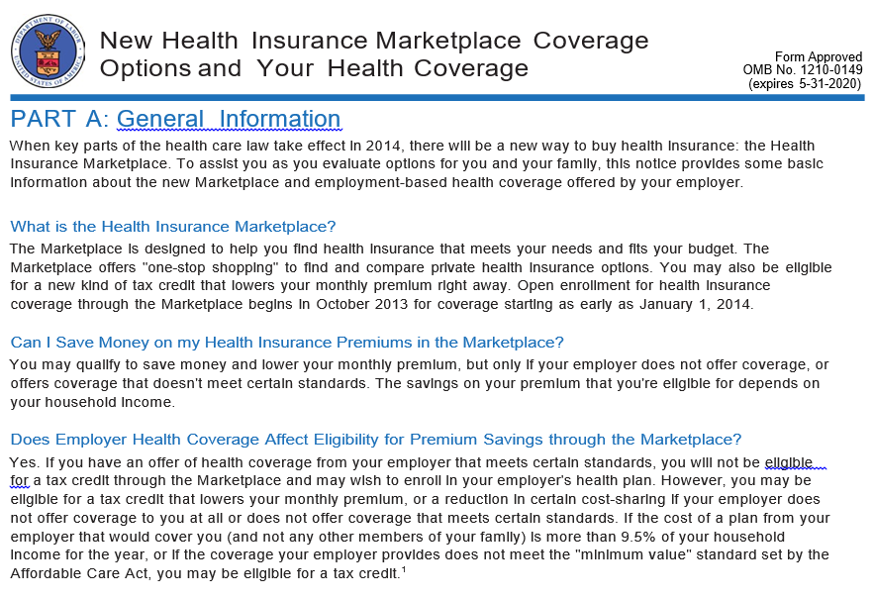

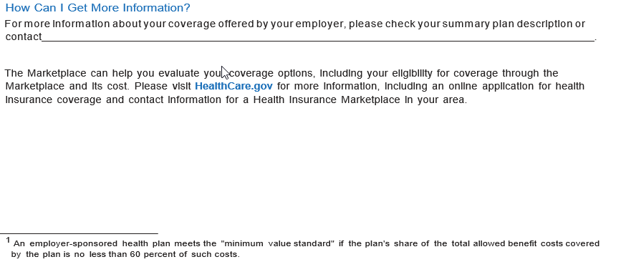
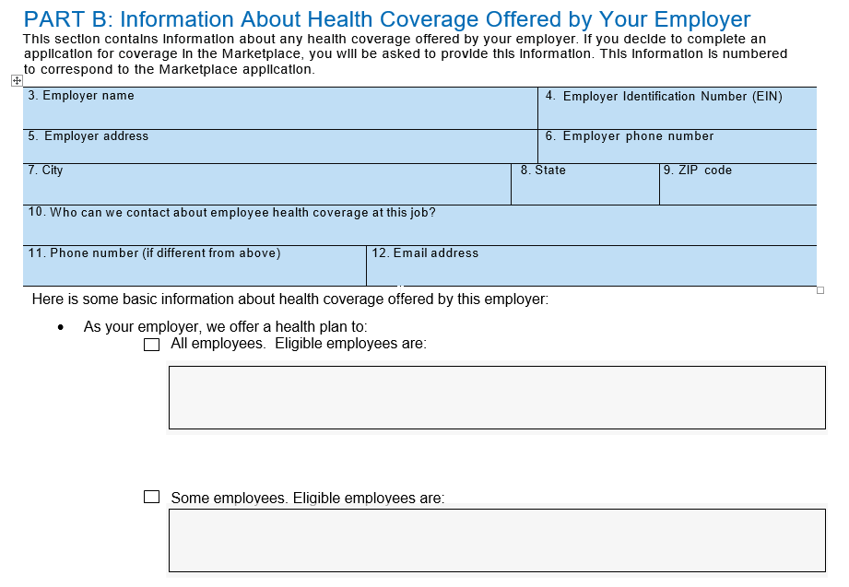
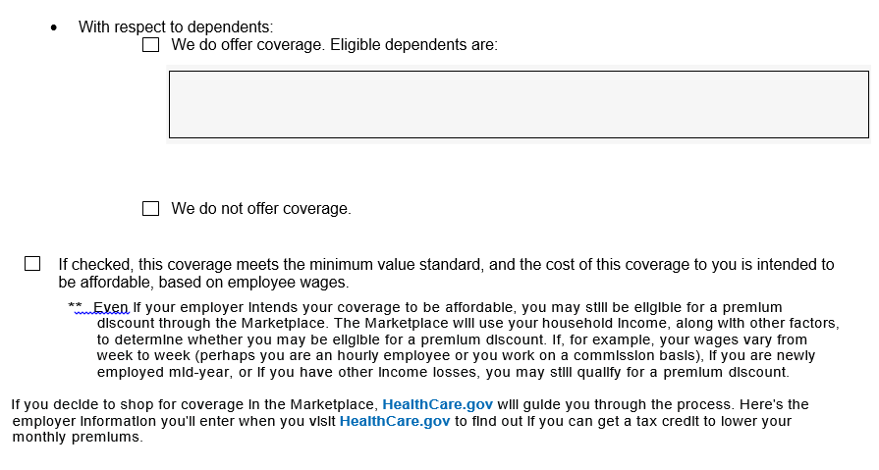
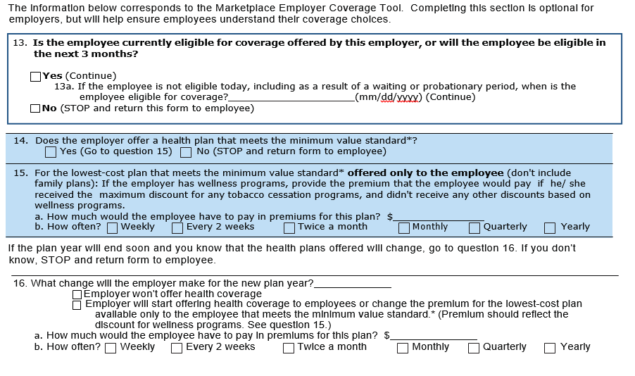

- An employer-sponsored health plan meets the "minimum value standard" if the plan's share of the total allowed benefit costs covered by the plan is no less than 60 percent of such costs (Section 36B(c)(2)(C)(ii) of the Internal Revenue Code of 1986)
MODEL INDIVIDUAL CREDITABLE COVERAGE DISCLOSURE NOTICE

Important Notice from Your Employer-Sponsored Health Plan
About Your Prescription Drug Coverage and Medicare

Please read this notice carefully and keep it where you can find it. This notice has information about your current prescription drug coverage with your employer-sponsored health plan and about your options under Medicare’s prescription drug coverage. This information can help you decide whether or not you want to join a Medicare drug plan. If you are considering joining, you should compare your current coverage, including which drugs are covered at what cost, with the coverage and costs of the plans offering Medicare prescription drug coverage in your area. Information about where you can get help to make decisions about your prescription drug coverage is at the end of this notice.

There are two important things you need to know about your current coverage and Medicare’s prescription drug coverage:

1. Medicare prescription drug coverage became available in 2006 to everyone with Medicare. You can get this coverage if you join a Medicare Prescription Drug Plan or join a Medicare Advantage Plan (like an HMO or PPO) that offers prescription drug coverage. All Medicare drug plans provide at least a standard level of coverage set by Medicare. Some plans also may offer more coverage for a higher monthly premium.

2. Your employer-sponsored health plan has determined that the prescription drug coverage offered by your employer-sponsored health plan is, on average for all plan participants, expected to pay out as much as standard Medicare prescription drug coverage pays and is therefore considered Creditable Coverage. Because your existing coverage is Creditable Coverage, you can keep this coverage and not pay a higher premium (a penalty) if you later decide to join a Medicare drug plan.

When Can You Join a Medicare Drug Plan?
You can join a Medicare drug plan when you first become eligible for Medicare and each year from October 15 to December 7.

However, if you lose your current creditable prescription drug coverage, through no fault of your own, you will also be eligible for a two (2) month Special Enrollment Period (SEP) to join a Medicare drug plan.

What Happens to Your Current Coverage If You Decide to Join a Medicare Drug Plan?
If you decide to join a Medicare drug plan, your current health coverage may be affected. However, in most situations, self-funded group health coverage with prescription drug coverage will not be affected if a member decides to join a Medicare drug plan.

If you do decide to join a Medicare drug plan and drop your current health coverage, be aware that you and your dependents may not be able to get the coverage back until the next open enrollment period. The exception to this is a ‘change in status’ event that causes a loss of other coverage.

When Will You Pay a Higher Premium (Penalty) to Join a Medicare Drug Plan?
You should also know that if you drop or lose your current coverage with your employer-sponsored health plan and don’t join a Medicare drug plan within 63 continuous days after your current coverage ends, you may pay a higher premium (a penalty) to join a Medicare drug plan later.

If you go 63 continuous days or longer without creditable prescription drug coverage, your monthly premium may go up by at least 1% of the Medicare base beneficiary premium per month for every month that you did not have that coverage. For example, if you go nineteen months without creditable coverage, your premium may consistently be at least 19% higher than the Medicare base beneficiary premium. You may have to pay this higher premium (a penalty) as long as you have Medicare prescription drug coverage. In addition, you may have to wait until the following October to join.

For More Information About This Notice or Your Current Prescription Drug Coverage…
Contact the person listed below for further information. NOTE: You’ll get this notice each year. You also will get it before the next period you can join a Medicare drug plan, and if this coverage through your employer-sponsored health plan changes. You also may request a copy of this notice at any time.

For More Information About Your Options Under Medicare Prescription Drug Coverage…
More detailed information about Medicare plans that offer prescription drug coverage is in the “Medicare & You” handbook. You’ll get a copy of the handbook in the mail every year from Medicare. You also may be contacted directly by Medicare drug plans.

For more information about Medicare prescription drug coverage:
- Visit www.medicare.gov.
- Call your State Health Insurance Assistance Program for personalized help. (See the inside back cover of your copy of the “Medicare & You” handbook for their telephone number.)
- Call 1-800-MEDICARE (633-4227). TTY users should call 1-877-486-2048.

If you have limited income and resources, extra help paying for Medicare prescription drug coverage is available. For information about this extra help, visit Social Security on the Web at www.socialsecurity.gov, or call them at 1-800-772-1213 (TTY 1-800-325-0778).

Remember: Keep this Creditable Coverage notice. If you decide to join one of the Medicare drug plans, you may be required to provide a copy of this notice when you join to show whether or not you have maintained creditable coverage and, therefore, whether or not you are required to pay a higher premium (a penalty).

[Optional Insert - Entities MAY choose to insert the following information box if they choose to provide a personalized disclosure notice.]

Medicare Eligible Individual’s Name: [Insert Full Name of Medicare Eligible Individual]
Individual’s DOB or unique Member ID: [Insert Individual’s Date of Birth], or [Member ID]

The individual stated above has been covered under creditable prescription drug coverage for the following date ranges that occurred after May 15, 2006:

From: [Insert MM/DD/YY] To: [Insert MM/DD/YY]
From: [Insert MM/DD/YY] To: [Insert MM/DD/YY

Date: [Insert MM/DD/YY]
Name of Entity/Sender: [Insert Name of Entity]
Contact--Position/Office: [Insert Position/Office]
Address: [Insert Street Address, City, State & Zip Code of Entity]
Phone Number: [Insert Entity Phone Number

REQUIRED ANNUAL ELECTRONIC DISCLOSURE NOTICE

TO THE CENTERS FOR MEDICARE AND MEDICAID SERVICES

CREDITABLE COVERAGE DISCLOSURE NOTICE TO CMS – Group health plans that provide prescription drug coverage to Medicare Part D eligible individuals must file a Disclosure Notice to the Centers for Medicare and Medicaid Services (CMS) on an annual basis, and upon any change that affects whether the prescription drug coverage under its Plan is creditable or non-creditable. CMS requires electronic transmission of the required annual disclosure notice and indicates that this is the sole method for compliance with this requirement.

The annual disclosure notice is due to CMS within 60 days after the beginning of the plan year for which the health plan is providing the disclosure. For example, if your plan year is January 1 - December 31, 2020, the disclosure notice is due to CMS by approximately February 29, 2020.

An overview of the regulatory requirements, instructions for completing the electronic disclosure form, and the date by which the filing is due each year are located on the CMS Web site.

- Go to: www.cms.hhs.gov/CreditableCoverage

- On the left side menu, click on “Disclosure to CMS Guidance and Instructions.” Complete instructions are provided, including screen shots of the disclosure form.

- To access the disclosure form and submit your disclosure, click on “Disclosure to CMS Form” on the left side menu.

If you have questions, please contact your Account Manager at MedCost Benefit Services.

